The Deadliest Mushroom and its Elusive Cure

The death cap mushroom poisons and kills more people every year than any other mushroom.[[ok? or does the “likely” in your original mean that the totals aren’t well known enough to make Death Cap the winner? If so, we can add it back in before “poisons”—or is it that this mushroom kills more people in the US than any other type of mushroom?]] Luckily, there may finally be a cure—but few doctors know about it yet.

When someone eats Amanita phalloides, she typically doesn’t experience symptoms for at least six hours. Sometimes symptoms take as many as 24 hours to manifest. Eventually she’ll suffer from abdominal pain that turns severe, vomiting, and diarrhea. This delay means she might not associate her symptoms with eating mushrooms and may seek treatment for a more benign illness like stomach flu. To make matters worse, these symptoms can lessen after several days. During this so-called “honeymoon” phase, she might forget about eating mushrooms completely.

Meanwhile, the poison stealthily destroys her liver. It binds to and disables an enzyme responsible for making new proteins. Without this enzyme, cells can’t function, and liver failure results. Without proper, prompt treatment, the victim can experience rapid organ failure, coma, and death.

A few mouthfuls of raw death cap mushroom can kill.

A few extremely adventurous mushroom connoisseurs have successfully removed toxins from slightly poisonous mushrooms such as the fly agaric, Amanita muscaria. Fly agaric is the archetypal red and white polka dotted mushroom beloved by Nintendo video game enthusiasts and nature artists. Cooking this mushroom thoroughly in a large amount of water removes the water-soluble toxins so the nutty-tasting mushroom can be enjoyed with no harm.

Despite folk lore to the contrary, the death caps’ deadliest toxins, called amatoxins, can’t be removed this way. Nor can amatoxins be destroyed by any conventional cooking method, such as boiling or baking. Freezing or drying the mushrooms also fails to remove any amount of amatoxin, instead preserving the mushroom to wreak havoc later.

[[I suggest adding the “why so common” part of the story here. I pasted in text from the other document]]

Many people who suffer from death cap poisoning claim the mushroom was by far the most delicious they’d ever eaten. It doesn’t taste remotely like death—many people who are poisoned claim the mushroom was the most delicious they’d ever eaten.

Its appearance doesn’t scream deadly, either: Its early “button” stage closely resembles immature edible white species, including the common field mushroom Agaricus campestris. Full-size Amanita phalloides is reminiscent of other innocuous mushrooms. In California, a number of immigrants have erroneously harvested the mushroom, confusing it with the edible paddy straw mushroom Volvariella volvacea, which is harvested in Asia.

[[these are great details and quotes but unfortunately are slightly too technical for our audience]]

[[we’ll have a section break here]]

Upon death cap ingestion, about 60 percent of the amatoxins travel directly to the liver. Poisoned liver cells spit out amatoxins into the nearby gall bladder, where the amatoxins get incorporated into bile salts and are sent out into the blood. The poisoning cycle repeats when the bile salts bring the amatoxins back to the liver.

The other 40 percent of initial amatoxins make a beeline to the kidneys, which serve as the blood-waste treatment center of the body. Healthy kidneys can extract amatoxins from the blood and send them to the bladder, but only if the victim stays sufficiently hydrated. (After the liver fails from amatoxin poisoning, the kidneys do as well.) If the patient still has liver and kidney function and enough fluid to urinate regularly, she can essentially pass the still-intact amatoxins out in urine, like the smallest, deadliest kidney stone.

This ability of the kidney to expel amatoxins is rare among liver poisons. Until the kidneys kick out every last bit of poison, amatoxins continue damaging the liver. To keep the amatoxins from causing damage, “the money is in the biliary tract,” says S. Todd Mitchell of [name his institution here], who is the principal investigator of a nationwide open clinical trial to treat amatoxin poisoning.

Mitchell and his colleagues are testing Silibinin, a new drug derived from the plant milk thistle, Silybum marianum. When administered intravenously, it sits on and blocks the receptors that bring amatoxin into the liver, thus corralling the amatoxins into the blood stream so they can be expelled by the kidneys faster.

Mitchell and his team have treated more than 60 patients suffering from amatoxin poisonings. Every patient who still had intact kidney function and was started on the drug within 96 hours of eating mushrooms has survived. Only a few patients sought treatment too late. [[Do you happen to know their fate? If they died or got liver transplants, maybe mention it here. If you’re not sure, that’s fine]]

So why don’t more people know about the wonders of this milk thistle drug? The research hasn’t been published yet—60 patients isn’t enough to confirm that Silibinin really is the liver savior it seems to be. “When we present to FDA it will be a slam dunk for approval,” Mitchell says. “The drug has virtually no side effects, it’s very well tolerated, and if used correctly it’s awesomely effective.”

“Patients go into early renal failure for two reasons,” Dr. Mitchell explains.[[is he speaking about renal failure in general here, or specifically about amatoxin?]] “One, they just present so late that their kidneys have already shut down. Or Two, more commonly, they’re just not aggressively hydrated enough by the treating physicians. That unfortunately seems to be a problem particularly in patients who are transferred to liver transplant centers.”

[[this is interesting but gets a little bit away from the main point of the poisoning]]

Medical treatment can go awry in the early stages of amatoxin poisoning. Poison control centers often prescribe activated charcoal to prevent poisons from being absorbed by the gastro-intestinal tract and causing liver damage. This works well for acetaminophen overdose and other poisonings, but by the time a patient usually seeks medical assistance, amatoxins have traveled well past the GI tract.

Part of the challenge of recognizing the symptoms of amatoxin poisoning and properly treating it is that mushroom poisonings are relatively rare. The first time a physician treats a patient for amatoxin poisoning, Mitchell explains, is likely to be her last.

[[Section break here for the history and botany sections]]

The death cap mushroom is an invasive species from Europe. It became such a world traveler because humans spread the mushroom’s spores around like glitter at a kids’ glitter party.

Fungi such as the death cap are ectomycorrhizal, meaning that they live symbiotically on the roots of trees. The fungus extends from the roots to form a network in the soil, called a mycelium, which is much finer than tree roots. The mycelium can more easily reach nutrients like nitrogen and phosphorous than the tree can, and it trades these nutrients with the tree in exchange for sugars, which the tree makes using photosynthesis.

A mushroom is the love child of two sexually compatible mycelia. Mushrooms in turn make tiny spores that easily disperse and can grow into new mycelia.

In the 19th century, people tried introducing their favorite trees to new continents. Seeds were planted but quickly died. Nothing seemed to help until someone had the bright idea to bring seedlings in pots with their native soil. The soil worked like a charm. The trees grew smashingly, but people didn’t know they had spread soil microbes, such as fungal spores, along with the trees.

A few researchers in the mid-20th century did notice that some mushrooms seemed to have appeared in new areas, but because they lacked a historical baseline for fungal diversity, nothing could be proven. Most scientists simply assumed the death cap was native to both Europe and the United States.

Anne Pringle became interested in death cap as a post-doctoral fellow studying [[was she studying botany? Or fungi or microbiology or something?]] at the University of California-Berkeley. She was learning the local mushrooms by collecting them in the small canyon behind her house. She brought one sample to her advisor, Tom Bruns, who identified it as Amanita phalloides. He then hinted about an enticing rumor among the amateur mycological community that the death cap wasn’t actually native to California.

Pringle admitted the idea was interesting but didn’t think too much about it at first until Bruns left some not-so-subtle hints that she should investigate, such as leaving drawings of skull and crossbones on her desk.

Pringle quickly learned that scientists in the early 20th century had been using descriptions to identify death cap that were so broad they encompassed several other species. By sequencing the DNA of old, dried specimens in collections across the country, she found that all specimens labeled before 1938 were actually different species of Amanita. While other North American mushrooms had much longer records in herbaria, the death cap made a sudden appearance in 1938, and became increasingly common after that year.

Pringle also sequenced the DNA of wild A. phalloides mushrooms picked in the United States and Europe. She found much less genetic variation in U.S. mushrooms. That indicated that the species had started in Europe and that the U.S. mushrooms had undergone a “population bottleneck” in which a mere handful of individuals had colonized the continent

Why were most scientists wrong about death cap? Prior to Pringle’s discovery, known invasive fungi fell exclusively into the category of plant or animal diseases, such as the one that wiped out the American chestnut. These fungi were ones we can see, that cause obvious symptoms.

The death cap can’t live without its tree host. In order to become invasive, A. phalloides underwent something that was hitherto undocumented with ectomycorrhizal fungi: a host shift. The fungus somehow switched from being able to grow only on European oak roots to growing on a completely different oak species, the California live oak. Not only was it able to colonize a new species of oak, but in the United States it has also been found to grow on native pines.

A shift from partnering with a deciduous oak to canoodling with a coniferous pine tree is a very large step for a fungus. Pringle’s discovery shook up scientists’ ideas of what it means to be a symbiont.

The death cap is widely distributed in the United States. Based on the weather patterns within its native range, it appears to have spread as far as tolerable conditions allow on the East Coast. But there are still areas in the Pacific Northwest that it should be able to live in but where it hasn’t yet been recorded.

With this long history of confusion about whether or not Death Cap is native, combined with the fact that it’s still spreading on the West Coast, it’s small wonder people accidentally harvest and eat it. Similarly, it’s no wonder that people intentionally eat it: It’s large and meaty, it’s often plentiful, and it smells delicious.

Even very experienced mushroom hunters aware of both the historical confusion and the death cap’s resemblance to edible fungi have been poisoned by Amanita phalloides. Because the mushroom is so deadly and can grow side by side with edible species, one wrong mushroom picked in the failing light can invite disaster.

If you ever suspect you may be suffering from mushroom poisoning, ask your doctor to call Mitchell in Santa Cruz, California, and request to be enrolled in the milk thistle treatment study. He will ship Silibinin to anyone, anywhere in the world.

And remember to stay hydrated if you want to live.

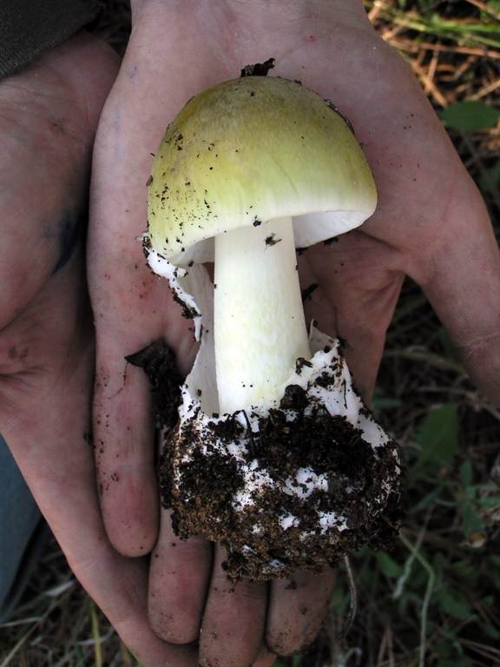
Photo credit: Franck Richard

